**Nikola Tesla's Ether Technologies in practice**

# Goran Marjanovic, BScE[1]

# Abstract:

The claim of science that ether does not exist is the greatest logical error of modern science, which it attempts to overcome by introducing an even less known spectrum of hypothetical phenomena such as dark matter, dark energy, quasi-particles like (never detected) “graviton”, “photon” and similar. By returning ether to science, all these entities created as a result of the "mental acrobatics" of theoretical physicists would become completely unnecessary, Nikola Tesla's ether technologies would be returned to the scientific domain and become the basis of all future technologies, the driving force of new scientific cognitions, numerous technical discoveries and actually the impulse and the driving force of the third industrial revolution of humanity..

Ether phenomena analysis, suggested corrections and supplements that enrich valid theories, reaffirm numerous (currently controversial) Nikola Tesla ideas and set his ethereal Technology interpretations to the scientific framework, are expounded in the text “About ether” [3].

In this paper I will present the results of my own researches and the measurements performed.

# KEYWORDS: Ether, Aether, Michelson Morley, Maxwell, Hertz, Tesla, Einstein, Relativity, Dark energy, “Pyramid of the Sun”, Rtanj

# Introduction

**Nikola Tesla was extremely successful inventor and futurist** best known for his contributions to the design of the modern alternating current electricity supply system, many new and amazing phenomena such as rotating magnetic field, glowing of wireless vacuum tubes and many other high frequency effects which amazed the world. His contribution to the advancement of science and the technological progress of civilization is enormous. **However many believe that the Nikola Tesla is the most underrated and misinterpreted scientist and inventor of all times.** Such an opinion is reasonable bearing in mind that Tesla made X-rays before Roentgen, smash the atom before Rutherford, etc. According to research by the Croatian academician dr. Vladimir Paar [1], **Tesla was deprived of as many as 10 Nobel Prizes**.

After the rapid development, at the end of the nineteenth and early twentieth centuries, due to a series of circumstances, by its clumsy and rapidly adopted decision, science eliminates the ether from physics although all the theory foundations of modern electromagnetism, and its interpretation of the greatest scientists of that time were based on the theory of ether [2,3]. Moreover, Oliver Heaviside and his supporters revise the genuine equations of Maxwell's theory given in form of quaternions, hyper complex numbers, which, in its original form, next to transversal "E" and "H" components, included a “scalar part” also i.e. longitudinal ethereal vibrations whose propagation velocity is not limited - and - apart from its transversal components - theoretically can reach an arbitrarily high value. **The simplification of the original Maxwell equations and their reduction to a dimensionally lower - vector form, with the removal of the scalar part of the quaternion, eliminates the possibility of a high-quality description of longitudinal (etheric) vibrations. With the expulsion of the ether (the material carrier of EM vibrations) from science, this procedure completely eliminated the scientific basis for Tesla's original explanation of his "Non-Hertzian" technologies based on the longitudinal vibrations of the "luminiferous ether".**

And so - Tesla's ethereal technologies become pseudoscientific.

Still – his legacy is the source of inspiration for millions - even today.

How is that possible?

In my opinion - the explanation is very simple.

Science is a systematized knowledge in the form of testable explanations and predictions about the Reality. Since - anything that is not detectable and measurable - science can accept only as a hypothesis (or as postulate) supported by a valid scientific theories.

Nikola Tesla’s (most controversial) ideas about exploiting the radiant energy and its wireless sending at an arbitrary distance via his „Non-Hertzian“ technologies based on longitudinal vibrations of ether, were not (nor are today) in agreement with a valid doctrines. So – Nikola Tesla had to be (and still is) expelled from science - just as ether was thrown out from physics ... so that the theory of relativity - „limited“ with the speed of light value – becomes (and remains) valid ...

Yet, according to Tesla : „**Instinct** (intuition) **is something which transcends knowledge.** We have, undoubtedly, certain finer fibers that enable us to perceive truths when logical deduction, or any other willful effort of the brain, is futile.“

Obviously - Tesla was right. Every true **free-minded** investigator, searching for the truth and **feeling intuitively the power of his ideas** - returns to the ideas of Nikola Tesla - reconsidering them despite its great disagreement with the valid scientific theories.

According to modern science claims: „EM waves propagate **through empty space by themselves** without the need for a MATERIAL medium as its carrier and without any connection with the source of its origin (sections 4, 5 in [2])“.

For me the existence of sea waves without the sea (water) is very illogical and very difficult to imagine, so Tesla's interpretation is much more acceptable: „EM waves are complex vibrations of the Ether (material substance) which is the perfect fluid of special quality, which behaves as a solid to light (high frequency) and is transparent to matter, while it's effects can be felt through inertia (section 1.5 in [2])“.

From the first days of theoretical physics studies, more than 40 years ago, it was always clear to me that empty space is not really empty as the official science claims - though trying to fill it with hypothetical form of "quantum vacuum", “dark matter”, “dark energy” and similar phenomena - but there must be a very fine, subtle, material substance that fills it, called ether. This was also quite clear to the Tesla, Kelvin, Maxwell, Mendeleyev etc – and even to Einstein [3] …

The following section describes my experiments and measurements that speak in favor of the real existence of a material fluid like an ether..

1. **PIP image of the scalar field**

In the late 1980s, using special technology, Dr. Harry Oldfield developed „Polycontrast Interference Photography“ (PIP) system [4] that can visualize subtle-energy structures which can be correlated with biofield and alike energy phenomenon’s. Regarding Dr. H.Oldfield explanations „ambiental“ and/or human energy field interfere with photons – “energy packets” of light – or even what might be called “subtle energy photons” in some way. He believes that ambient (surrounding) light would be interfered with by the field both when the incident ray travelled towards the object and when the reflected ray bounced off the object. He devised a special computer programme which analyze the different light intensities being reflected from the person or object being scanned showing up a result of an energy field interaction with light converting this tiny changes into visible spectrum and showing them to us as different colors. In this way PIP system makes visible subtle-energy forms and interactions invisible to conventional optical/camera systems - giving us an insight into the subtle-energy counter-part and the ethereal template of reality.

Dealing with Tesla's technology, I realized that his claim that he did not use the "Hertzian" waves in his work, but rather of a completely different kind of waves he named “Non-Hertzian (section 1 in [2]. Studying the fundamental principles he applied in his famous "Magnifying Transmitter" [5], and the scientific analysis of highly competent experts for Tesla's work Dr. James F. Corum and Dr. Kenneth L. Corum [6], I constructed a coil of a very special design (Pic. 2) – significantly reduced but analogous to the structure of the "Extra coil" that Tesla used in his Colorado Springs experimental setting. According to my expectations, this “Special coil” was supposed to constitute a specific energy field whose qualities should be notably different from the energy field formed by the conventional construction of the secondary coil (Pic. 1).

One possible method of such expectations verification was Dr. Harry Oldfield’s PIP system.

The recording was done by the original "oldfieldsystems" software [4] and appropriate equipment on August 15, 2010 performed by Dr. Ljubo Ristovski, whose preliminary comment along with PIP recordings he made was sent to the Dr. H. Oldfield team.

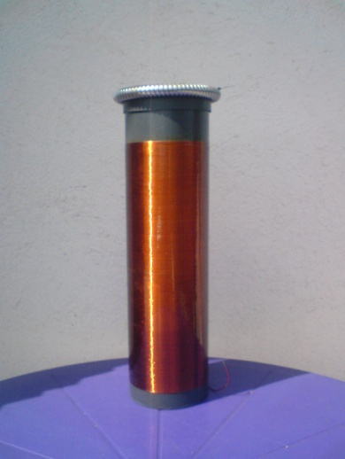 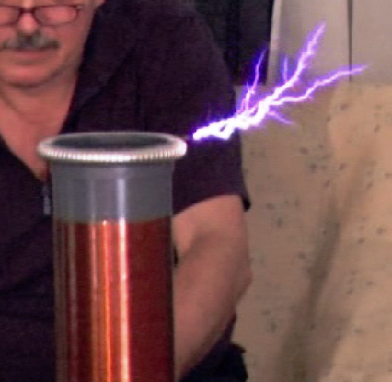 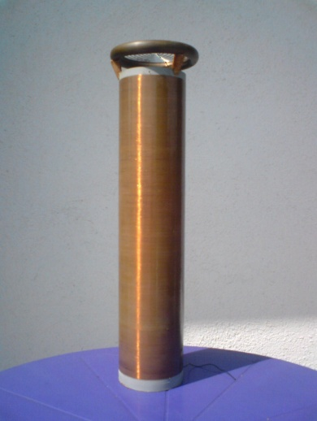

Pic 1: Classical Tesla coil Pic 1a: Classical Tesla coil in function Pic 2: Special Tesla coil

  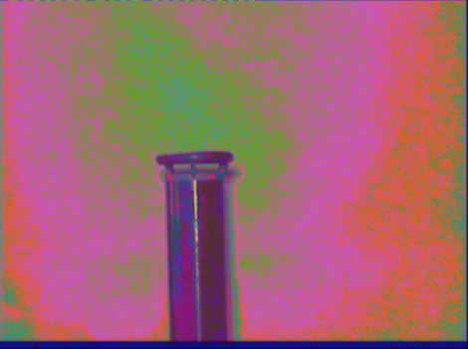

Pic 5: PIP photography of special Tesla coil

Pic 4: PIP photography of classical Tesla coil

Pic 3: PIP photography of “Ambient field”

The picture 4, PIP photography of classical Tesla coil in function, clearly shows that this coil did not change structure of ambient field significantly, in spite of the fact that input power was over 400 W and secondary voltage was about 300,000 volts which resulted in strong sparks from the „Top load" – whose length was about 20 cm (Pic. 1a). It is more than interesting that neither spark nor a glowing needle - that melted during coil operation due to high current density - are not visible at the PIP recording (Pic.4) ?!

However, **on the picture 5, PIP recording of Special Tesla coil acting, there is an extremely large change in the ambient field structure** though this coil was excited with much lower input power that was below 20 W, so there was no visible sparks. Still it can be clearly seen quite different ambient-energy structure that indicate the **constitution of a “three-dimensional standing wave” or a scalar field** generated by the “Special Tesla coil” that is expressed in green-colored ovoid (egg-shaped) energy form embedded within pink-colored “energy shell”.

In the expert analysis from “Oldfield Systems Ltd”, I received on September 1, 2010 it was written:

“Dr. Harry Oldfield confirm that the Tesla coil is definitely creating a standing wave, possibly scalar in nature, and is columnating a flare of energy which is green in colour which is often associated with healing radiation in connection with balance and well-being, therefore Dr Oldfield is in agreement with Dr Ristovski's analysis in this case.”.

For me, that was a strong confirmation of the Tesla’s claims that he uses waves that **are not** of “Hertzian” nature, that is EM waves produced by Heinrich Rudolf Hertz, i.e. the classical, transversal, vectorial, EM waves.

Based on further research in my laboratory for Tesla Technology investigations and insights into the knowledge of other researchers as well as ancient knowledge [7], I am completely sure now that these images actually verify the changes of the ethereal structure that is “woven” into the "space", initiated by the action of the "lambda-quarter-helicoidal resonator" - the special coil constructed according to specific Tesla's "Non-Hertzian" principles which could not be achieved by a conventional coil he used before Colorado Springs, which constitute the classical EM field and characterize transmitters of the "Marconi" type.

**Therefore, I regard this recordings as a proof of the truth of Tesla's claims that he does not use the Hertzian wave in his work but "the longitudinal excitation of ether" !**

1. **Energetic phenomena research in “AP BPS”, Visoko, BiH**

During energetic phenomena research in APBPS in September 2016 [8], drone aircraft and a specially adapted hardware/software solution was used for recording a spatial distribution of the electric field strength above the APBPS localities.

Measurements performed showed various configurations of "E" fields above different localities, but the spatial distribution of the electric field above the Visocica hill, named “Bosnian pyramid of the Sun” is definitely the most interesting, absolutely "non-standard" – but very regularly structured (!)

Measurements were realized using the drone aircraft and equipment (Pic 6) specially configured for this type of research because of limitations in weight (max. 800 g) and large requirement in terms of the measuring equipment sensitivity, the width of the measuring range, the purpose of recording and registering Vrms signals during the drone flight due to the necessity for the subsequent analysis of signals amplitude and frequency spectra (FFT). All these requirements were fulfilled by choice of the suitable hardware and software so the total weight of equipment was only 788 grams, which is below the allowed limit of 800 grams for the drone aircraft model used.

|  |  |
| --- | --- |
| Oprema7  Pic 6, “Flying lab”: VF-Broadband amplifier, special /light weight/, OBD LAB, Belgrade; PC osciloscop OWON, VDS1022; Tablet computer, I.Onik, Quad Core, Win 8.1 |  |

Although a very complex, the chosen method enabled us to obtain a 3-D structure of energy fields intensity measuring Vrms value (Root Mean Square / "quadratic mean") on chosen positions in the vertical plane to a height of about 50 meters and in the horizontal plane to a diameter of about 150 meters!

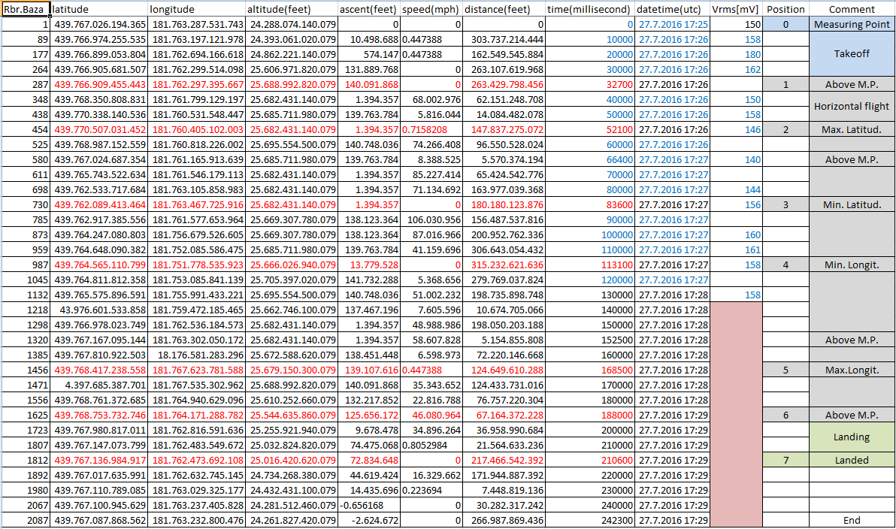

Pic 8, drone flight parameters and values registered by measuring equipment

Details about flight trajectory and registered values (GPS coordinates, altitude, speed, measuring point-drone distance, time of flight, Vrms in specific positions, comments) for this location are given in picture above (Pic 8).

**It is really more than interesting** that the value of the electric field strength ("E") **initially increase** during the drone’s takeoff (position 0-1) **to the maximal Vrms value, and then**, during the further aircraft’s height increasing, the registered Vrms value starts to **decrease** and at the maximal height (pos.6) got a value close to the one measured at the starting point (position 0) at the real top of the Pyramid of the Sun!

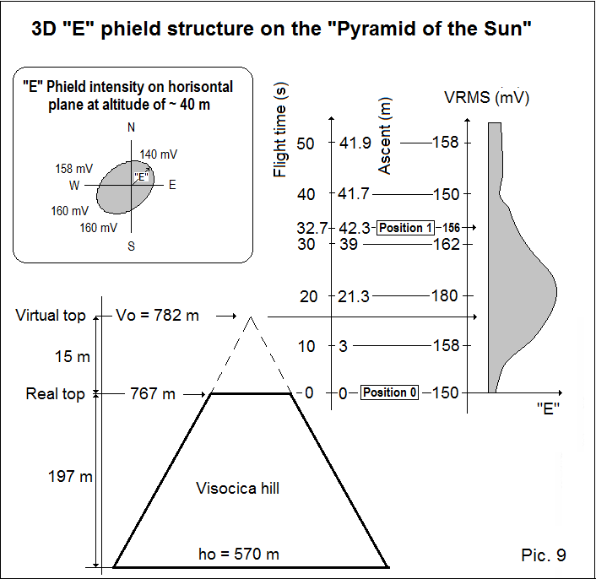

A more detailed view of the registered values changes during vertical flight is shown in picture 9, given left, where it can be clearly seen that the registered “E“ field intensity is largest in the 20th second of flight during taking off, in position when the drone attained a height of about 21.3 meters.

This is really an extraordinarily unusual fact - because this point corresponds to the virtual top of the Pyramid of the Sun ?!

Also, analysis of the registered Vrms value during the horizontal flight at a height of about 40 m, shows slightly increased values in the south-southwest zone (upper left corner of pic. 9), suggesting that "energy beam" is not vertical but is slightly inclined in the direction of the south-southwest.

On the basis of drone flight parameters and values registered by measuring equipment at appropriate spatial positions we get "E" fields intensity distribution in the horizontal and vertical plane, shown in pic.9. The synthesis of these data gives us a 3-dimensional i.e. volumetric "E" field structure.

It is obvious that the energy field above the Pyramid of the Sun has the shape of an elongated, irregular, ellipsoid, with the highest energy density in “central” point, at a height close to the virtual height of the pyramid, a little inclined in the direction of south-southwest.

Variable energy density expressed in the form of a variable electric field strength, of noticeable regularity, which grows with a height to its “center” and then decline, in both - in the vertical and in the horizontal plane – from the "central point" to the left and to the right . By values synthesis we get the spatial energy distribution which has the shape of elongated ball, or "energetic ellipsoid" in the certain space area above the top of this facility with the highest energy density in its center. It's really very unusual and very interesting form of energy density distribution.

Exactly such **“spherical”** **structure of energy field** form with adequate regularity that is detected here by measuring performed, **indicates a** **SPATIAL** (3D) **Volumetric Standing Wave existence**. In scientific terminology this term corresponds to the **“Scalar field”** notion.

Such an energy form can be formed by conventional EM mechanisms, but only with extremely complicated setup and exceptionally complex equipment that is not present here. However - what is more important and significant - **a standing wave pattern - by definition - is a vibrational pattern created within a material medium !**

Which material medium we have here if ether does not exist ?

The fact that here registered energy configuration is not the result of classical Hertzian technology operation and that it has very regular spheroidal form indicates that the Pyramid of the sun is an energy machine whose function is close to the mechanism of Tesla's Non-Hertzian technology based on ethereal vibrations, quite analogous to the Tesla "Extra coil", the lambda quarter helical resonator, function [6].

1. **Measurements on Rtanj mountain**

Rtanj Mountain abruptly rises from the plains in the form of body limited with almost regular triangles thus making the "pyramidal structure" of extremely unusual geometry and structure: regular cavity, heterogeneous underground area - clusters, with different mechanical, magnetic and electrical conductivity, which gives it a very specific features of the “multidimensional resonance”. The base of Rtanj mountain is mainly composed of sandstone and rocks, and the higher parts consist of the limestone. All water flows through limestone, sinks, and then, in the lower parts, breaks out as a strong springs of water along the edge of the mountain.

This complex "mechanism" of watercourses combined with geometry and structural matrix of Rtanj mountain constitute a very sophisticated, subtle energy machine, which could be the result of stochastic natural processes but also a purposefully constructed object, probably with technologies unknown to us.

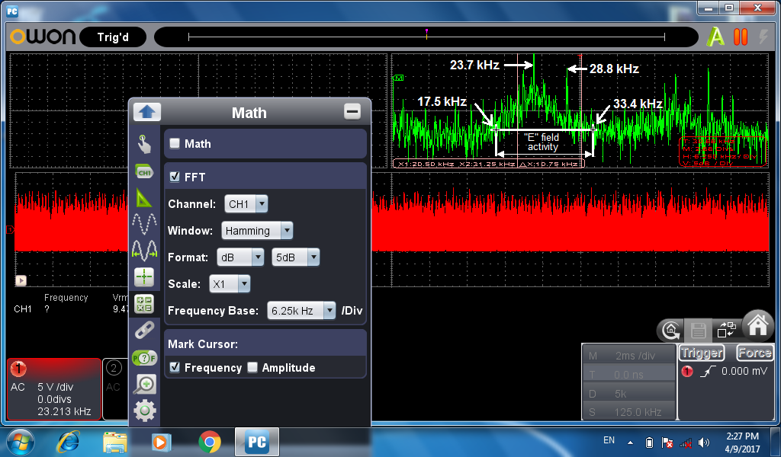

***Figure 10, "E" signal in the range 0.1 - 62.5 kHz.*** *A large electrical activity is visible in the area of 17.5 - 33.4 kHz.*

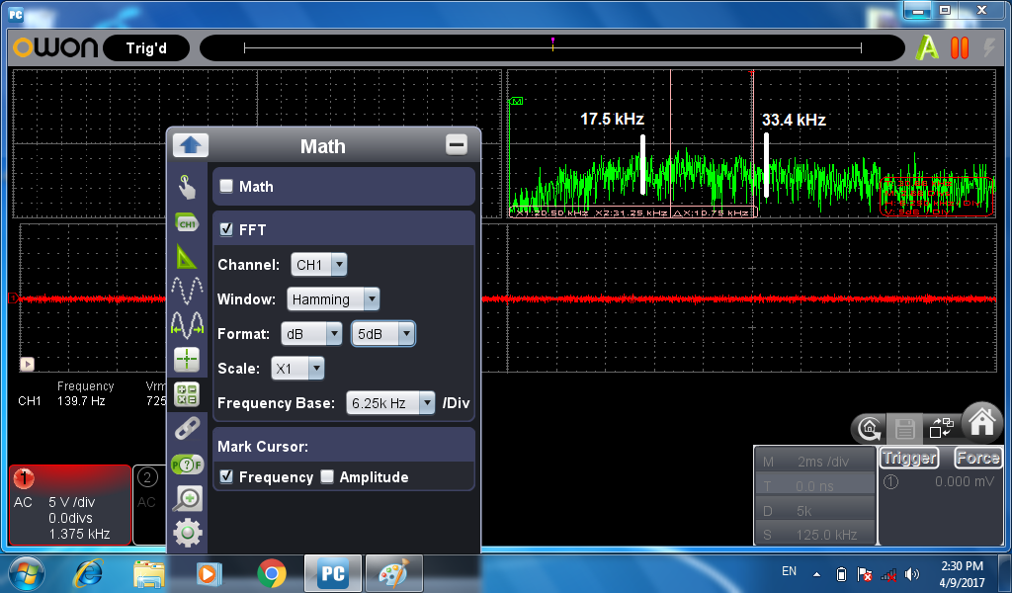

***Figure 11, "H" signal in the range 0.1 - 62.5 kHz.***

*There is no any significant magnetic activity in the same part of the frequency spectrum.*

Magnetoteluric and electrodynamics researches, realized in April 2017 [9], the mission "Rtanj", Serbia, are entirely consistent with our previously performed theoretical and practical investigations. Measurements performed indicate a deep connection, analogy and numerical agreement of geometric, structural and topological parameters of Rtanj mountain with the physical parameters of the radiation frequency of 28 kHz, also with the expected values according to the EDQ Model [10], and – with Nikola Tesla measurings [11] !

**The electric** ("E") **field signal registered at the top of Rtanj mountain,** in the frequency range from 0.1 kHz to 62.5 kHz, shown in Figure 10, indicate the really **emphasized electrical activity in the frequency range from 17.5 kHz to 33.4 kHz**. It is obvious that whole this range and especially its central part **is considerably raised.** At the same footage a **very strong signals at 23.7 kHz and 28.8 kHz are clearly visible.**

It is more than interesting that the signals with similar frequency (22.5 kHz and 28 kHz) were registered at the localities in the Archaeological Park of the Bosnian Pyramid of the Sun [see ref. 12] with completely different equipment of the same type. Namely, instead of measuring equipment used in these measurements (PC osciloscop OWON, VDS1022; Tablet computer, I.Onik, Quad Core, Win 8.1), during the measurement at the APBPS [12] a "Digital oscilloscope with FFT option, Agilent Technologies, model DSO3202A, 200 MHz, 1GSa / sec" was used. However we have registered a signals whose frequency was very close to the frequency signal registered in this measurements at the top of Rtanj mountain. This fact, despite their essentially different **but harmonious dimensions[2]**, **indicates a "resonant consent" and energetic coherence of the Rtanj mountain with facilities in APBPS!**

Figure 11 is a recording of magnetic signal (“H”) measurement in the range from 0.1 kHz to 62.5 kHz. On the magnetic signal frequency spectrum graph (shown in green) can be seen that **in the same part of the frequency spectrum in which previous measurement was performed with "E" field probe, there was not registered any significant magnetic activity nor any frequency segment “raising”.**

According to the definition (Wikipedia) of so-called **"Hertzian" electromagnetic waves**, classically, electromagnetic radiation consists of electromagnetic waves, which are synchronized oscillations of electric (E) and magnetic (H) fields that propagate at the speed of light through a vacuum. The diagram in the figure below shows the EM wave which propagates from left to right. The oscillations of the two E and H fields are cause and effect of each other, mutually perpendicular, and direction of energy and wave propagation (V) is perpendicular to both, forming **a vectorial, transverse oscillating wave** shown on picture below (pic 12).

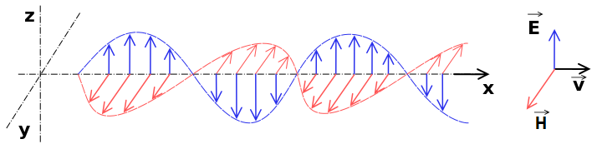

Pic.12 Conventional (“Hertzian”) electromagnetic wave

Comparing Figures 10 and 11, i.e. recordings of registered electrical and magnetic signals within corresponding frequency spectra (i.e. **F**ast **F**ourier **T**ransform charts, FFT) clearly shows the **complete absence of a magnetic component (“H”) of the EM signals registered in “E” domain, indicating that registered energetic phenomena have a “longitudinal electro-dynamic” form** [13].

In previous section (§ 2) it is shown that the “Pyramid of the Sun” geometry and its internal structure provide it the key features that multi-dimensionally resonant systems have, giving them a possibility of the 3D-standing wave patterns creation and considering that (by definition) **a standing wave pattern is a vibrational pattern created within a medium” this term can be correlated with ether. Analogously –** energy phenomenon registered in measurements on the top of the Rtanj mountain in April 2017 [9], and depicted with picture 10, can be very simply and logically explained by **a “subtle-energy flows” (energy beams) that can be strongly correlated with “ether wind” registered in a series of modern scientific institutes** (e.g. §10 in [3]).

1. **SBRG Measurements**

During one of their research missions realized in this region a few years ago, experts of the SB Research Group [14] performed numerous and complex measurements in my laboratory for the Tesla Technology research (Pic 13) on November 18, 2013. On this occasion, using extremely sophisticated scientific equipment, extremely unusual energy phenomenology was registered.

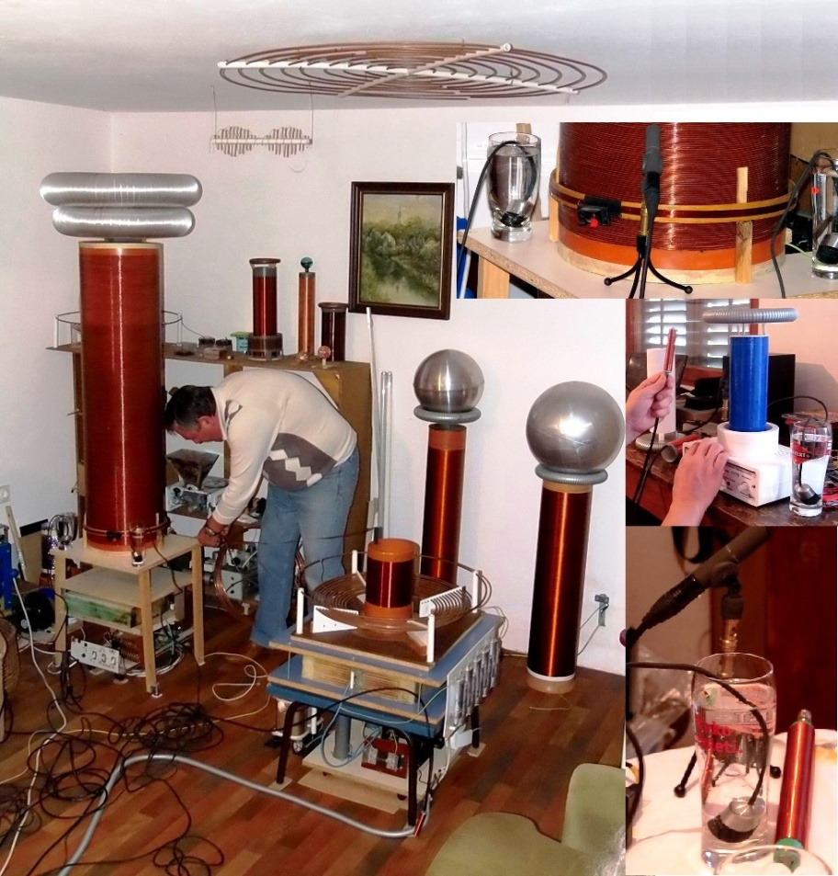

On this occasion, using extremely sophisticated scientific equipment, extremely unusual energy phenomenology was registered.

**Super Brain Research Group** **(SBRG)** is a multidisciplinary and international non-profit research organization with legal personality that aims to study the architecture, geometry, shape and materials of ancient structures in Europe.

Under the guidance of dr. Paolo Debertolis, one of the top SBRG team expert for energy phenomena investigations, sound eng. Heikki Savolainen made measurements with extremely sophisticated, high quality equipment.

Pic 13 G.Marjanovic laboratory for

Tesla Technology investigations

The measurement results are shown in the picture 14 below:

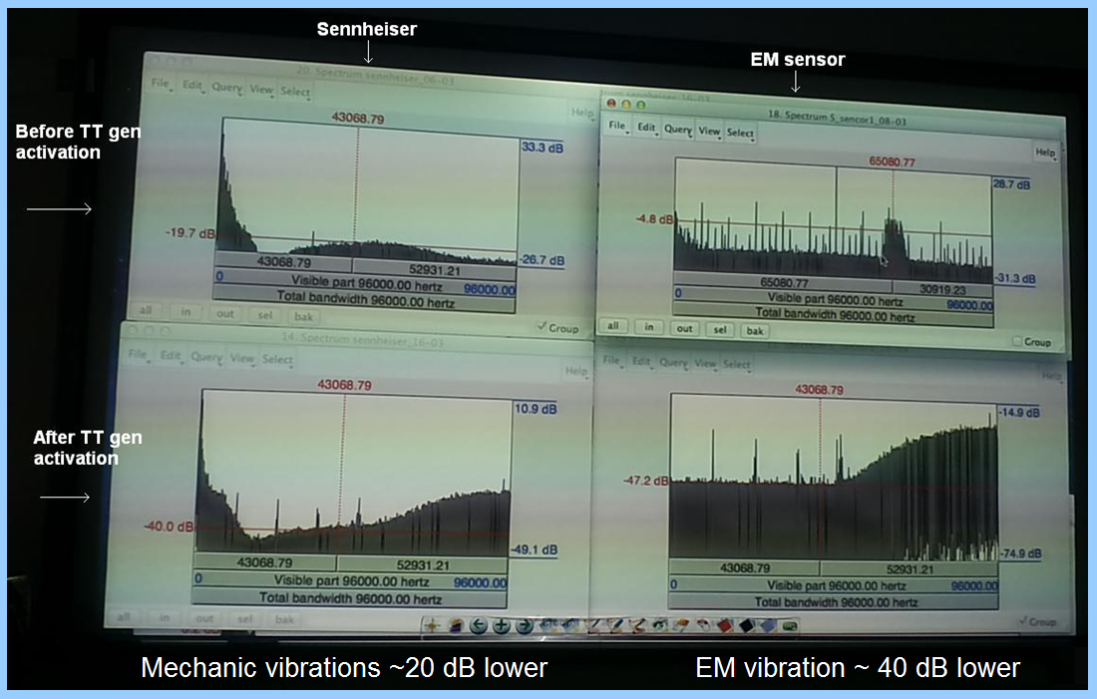

Pic 14 SBRG measurements in TT lab

Measurements comment, sound eng. H.Savolainen, quote:

*The source of above diagrams is recording with MOTU interface* [*http://motu.com/products/motuaudio/896mk3*](http://motu.com/products/motuaudio/896mk3)

*to 192 kHz / 24 bit resolution protools audio software version 9.06. AD gain control set to minimum (-60dB) because high noise level of the Tesla coil.*

*Unedited wav audio files. Analysis using Praat software in Belgrade 11/2013.*

*Used method is our archeoacoustics standard* [*http://www.sbresearchgroup.eu/index.php/en/research-papers/202-the-research-for-an-archaeoacoustics-standard*](http://www.sbresearchgroup.eu/index.php/en/research-papers/202-the-research-for-an-archaeoacoustics-standard) *where possible coherences in sync between mechanical and electromagnetic waves can be studied in same timeline. Sensors used in those diagrams are Sennheiser MKH3020 condenser microphone and Demiurg small 300Ω EM sensor.*

*Further analysis and verification of all sensor data collected in Barajevo will follow this spring.*

End of quotations.

The diagrams on the **top line** in Figure 14 show a mechanical vibration (infrasound, sound, ultrasound) frequency spectrum recorded in the frequency range 0 - 96 kHz (left) and EM vibration spectrum (right) in the same frequency range (ULF - LF) **BEFORE** the "Tesla Wave Generator" activation.

Then "Tesla Wave Generator" was activated for 30 seconds and then switched off.

The diagrams in the **bottom line** in Figure 14 show a recording of mechanical (left) and EM (right) vibrations spectrums in the range of frequencies 0 - 96 kHz **AFTER the "Tesla Wave Generator" operation.**

From measurements recorded, shown on Figure 14, it is easy to see that in the "second silence" the mean level of mechanical vibrations were reduced form -19.7 dB to -40 dB – accordingly **noise was lower by about 20 dB** - which is an extremely high value of noice damping !

Even more unlikely is the registered fact that after the operation of the Tesla Scalar Wave Generator (in the "second silence"), the "EM noise" level has been reduced from -4.8 dB to -47.2 dB, hence **“Electrosmog” was lower even for incredible 40 dB !!!**

Registered values are absolutely unexplainable from the aspect of classical science, but can be easily interpreted by returning the ether to science so that measured values can be logically explained as a reduced ether fluctuations which macroscopically manifests itself as a lower "Space Activity” or "Harmonization of the Ambient Field".

In my opinion decreased mechanical and electromagnetic activity illustrated by these measurements, is completely analogous to the calming of the undulated sea.

**Anyway these measurements are very solid scientific arguments that support "material-mechanical” properties of "** **quantum vacuum" and in this way reaffirm ether theories validity!**

**Conclusion:**

Since the universal phenomena of Reality have been created and exist long before the appearance of "Human being", no proper theory should depend on the logic structured through intellectual analysis that is contrary to the visible and measurable characteristics of natural phenomena. Unfortunately in modern science this is not the case. A classic example of such a disagreement in today's science is the assumption that the space is empty although the recent scientific measurements point to the vast difference between the experimentally measured values and the expected values of valid theories (Structure and form of galaxies, Blue shift, Aharonov-Bohm experiment ...).

The examples given in sections 1-4 indicate that the science's claim that ether does not exist is the greatest logical error of modern science which it attempts to overcome by introducing an even less known spectrum of hypothetical phenomena such as dark matter, dark energy, quasi-particles like (never detected) “graviton”, “phonon” and similar. All these entities resulting from “mental acrobatics” of theoretical physicists would become unnecessary - by returning ether to science. Especially because of the fact that many recent series of measurements, done by reputable scientists in renowned scientific institutions, confirmed the existence of such a phenomenon - what more - **performed by the same measurement method** (Michelson-Morley setup) on the basis of which the ether was expelled from science [3] !

In short - there are numerous scientifically-detectable anomalies that prove the fact that **there is a some material medium that exist as it it is shown in** § 1-4 and § 10 in [3]. I personally do not see any single reason for science not to accept its own experimental reality, correct its own postulates, return to its original settings and thus open the way to its further development and progress by providing a scientific and theoretical basis to a series of realistically existing and scientifically verified phenomena for which the existing theory has no explanation so that they still belong to the domain of pseudo-science.

**In this way, Tesla's technology will become the basis of all future technologies, the impetus of new scientific knowledge, numerous technical discoveries and actually a driving force and momentum of the third industrial revolution of humanity.**

In Belgrade, January 6, 2019 Goran Marjanović, B.Sc.E

**REFERENCE:**

1. Tesla - vizionar 21. stoljeća, Vladimir Paar, HAZU, <https://hrcak.srce.hr/file/35636>
2. “Nikola Tesla's Ether technology”, <http://users.beotel.net/~gmarjanovic/EtarTehNT_e.pdf>
3. “About ether”, <http://users.beotel.net/~gmarjanovic/O_Etru_e.pdf>
4. Polycontrast Interference Photography (PIP), <http://www.electrocrystal.com/pip.html>
5. Nikola Tesla Colorado Springs Notes 1899-1900, <http://www.shamanicengineering.org/wp-content/uploads/2014/07/Nikola-Tesla-Colorado-Springs-Notes-1899-1900.pdf>
6. James F. Corum, Ph.D, Kenneth L. Corum, A Technical Analysis of the Extra Coil as a Slow Wave Helical Resonator, <http://www.padrak.com/vesperman/A_Technical_Analysis_of_Tesla%27s_Extra_Coil_6.24.14.pdf>
7. Secret Of Sankhya: Acme Of Scientific Unification, G Srinivasan, <http://www.kapillavastu.com/>
8. Magnetotelluric and electrodynamics research, September 2016 mission: "Archaeological Park: Bosnian Pyramid of the Sun", Visoko, Bosnia-Herzegovina; <http://users.beotel.net/~gmarjanovic/ScWaveOnBP.pdf>
9. Magnetoteluric and electrodynamics Research, April 2017, the mission "Rtanj", Serbia, <http://piramidasunca.ba/bs/blogovi-3/goran-marjanovic-blog/item/11673-magnetotelurska-i-elektrodinami%C4%8Dka-istra%C5%BEivanja-april-2017-misija-%E2%80%9Crtanj%E2%80%9D-srbija.html>
10. Energy Density Quantization model, <http://users.beotel.net/~gmarjanovic/index.html>
11. Analogy of Tesla’s measurements , expected values by the KGE model and measurement results on Visočica, TESLA, SPACE-TIME AND BOSNIAN PYRAMID OF THE SUN, <https://www.scribd.com/document/203964613/Tesla-Space-Time>
12. ELECTROMAGNETISM AND TOPOGRAPHY OF THE BOSNIAN VALLEY OF THE PYRAMIDS, <http://piramidasunca.ba/eng/latest-news/item/11009-new-report-electromagnetism-and-topography-of-the-bosnian-valley-of-the-pyramids.html>
13. K. J. van Vlaenderen, A. Waser: “Generalization of Classical Electrodynamics to Admit a Scalar Field and Longitudinal Waves”, Hadronic Journal 24, 609, 2001
14. SB Research Group, <http://www.sbresearchgroup.eu/index.php/en/15-home-page-inglese/3-home-page-in-english>
15. Sound eng. Music prod. Heikki Savolainen, HSS PRODUCTION, [hssproduction@me.com](mailto:hssproduction@me.com), [www.hsspro.fi](http://www.hsspro.fi/)

1. http://www.teslascalar.com/en_galerija.html, "Energy Density Quantization model", http://users.beotel.net/~gmarjanovic/
2. Visočica hill (Pyramid of the Sun) altitude: P.S.alt= 782 m, Rtanj altitude: RT.Alt = 1565 m; **P.S.Alt= RT.Alt /2** ! **P.S.Alt= 782 m/4 =** (in terms of a quarter wavelength in wave mechanics) = **196 m**, that is almost identical to real height of Visocica hill **PSHeight = 197 m !** **Pyramid of the Sun and Rtanj distance is exactly 300 km** - that is decadal multiple of light velocity! Fact that operating frequency of the Nikola Tesla famous "World Wireless" Broadcasting system, Wardenclyffe tower, was just 28 kHz obviously is not strange nor accidental, bearing in mind that Tesla's is used Earth as a resonator ! Signals with same frequency of 28 kHz were detected on Rtanj in Serbia as well as on Pyramid of the Sun in Bosnia.